3. Gas Exchange and Respiratory Systems of Animals *Ch 46*

______________________________________________________________________________

I. Introduction *(1074-1077)*

A. Evolution of the Atmosphere and Oxygen Consumption

B. Anaerobic versus Aerobic Metabolism

C. Structures Necessary for Respiration

II. Diffusion: The Physical Mechanism of Oxygen Acquisition *(1074-1077)*

A. Diffusion

1. Definition

2. Importance

B. Factors Affecting Diffusion Rates

1. Concentration differences

2. Area across which diffusion occurs

3. Density of medium

C. Oxygen Availability in Different Habitats

III. Respiratory Surfaces *(1077-1079)*

A. Respiration Across Unspecialized Surfaces

1. Diffusion across body surfaces

2. Ventilation

B. Body Size and Specialized Respiratory Surfaces

C. Countercurrent Exchangers

1. How they do not work

2. How they do work

3. General importance in biology

4. Example from fish gill

5. Carbon dioxide elimination

IV. Tracheal Systems in Insects *(1078-1079)*

V. Respiratory Structures in Vertebrates *(1079-1083)*

# A. Fishes

# B. Amphibians

C. Mammals

03-1

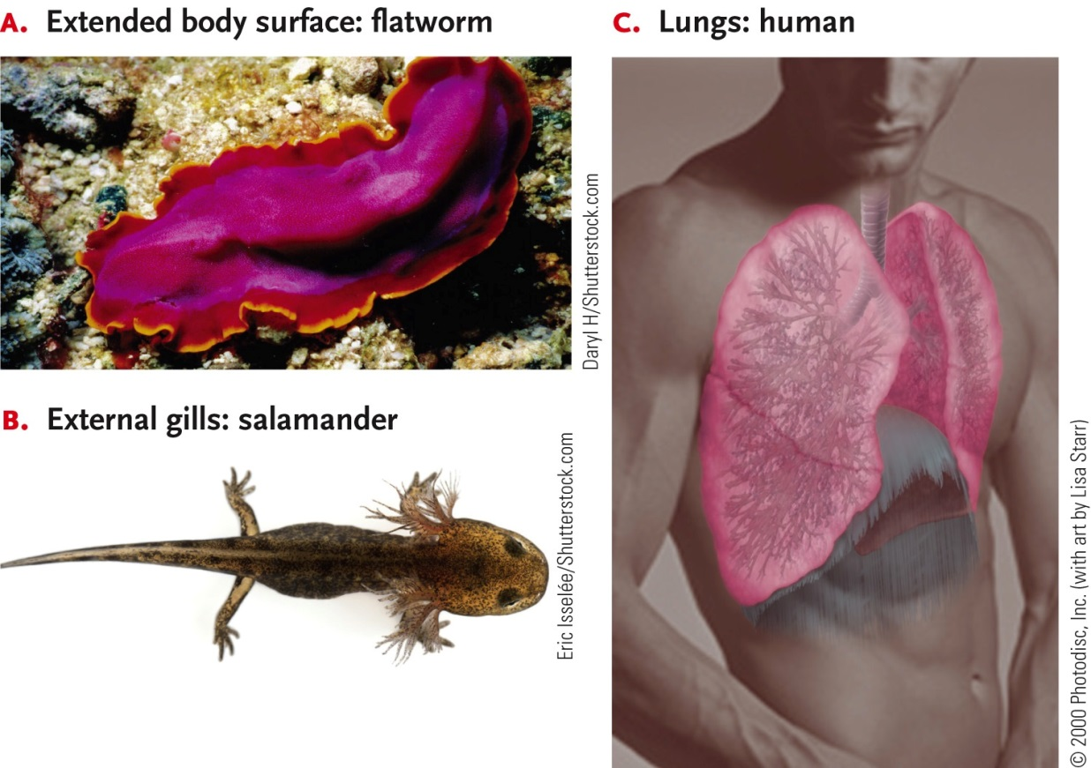

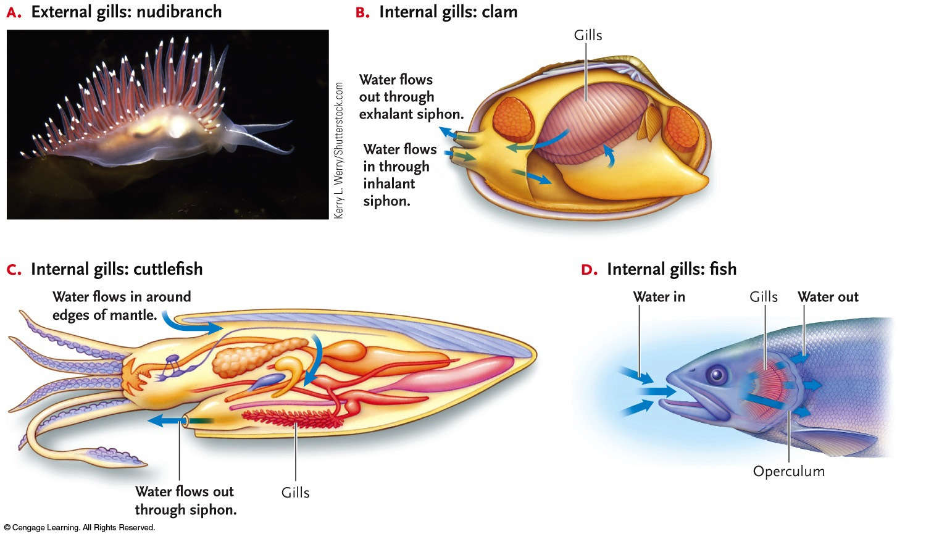

03-2

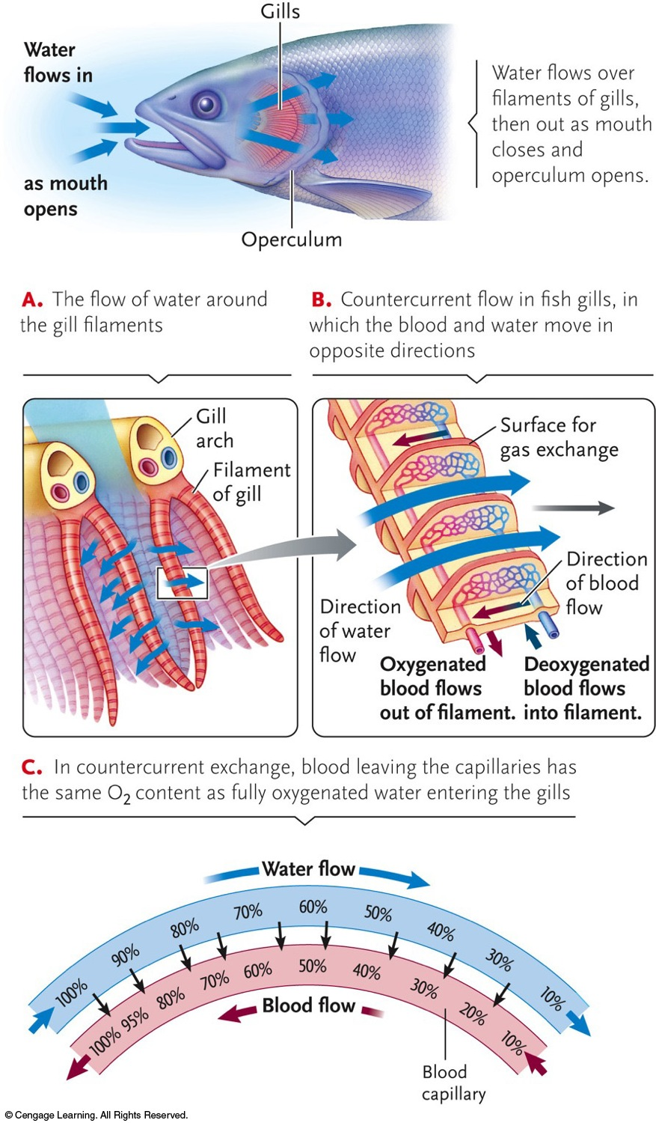

03-3

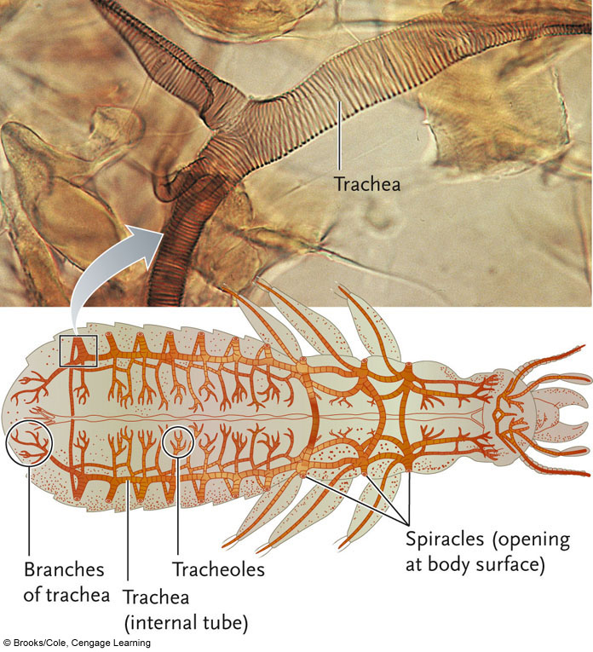

03-4

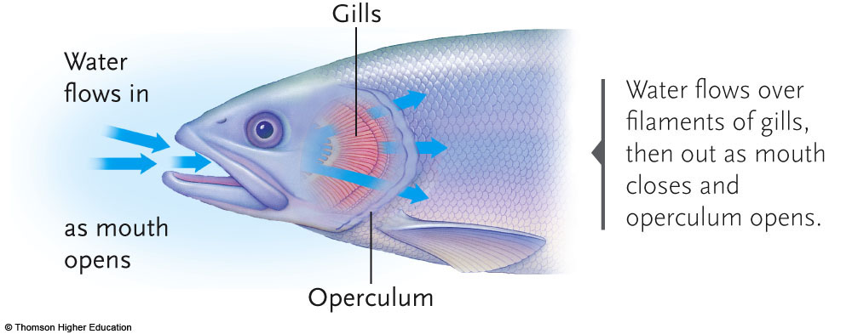

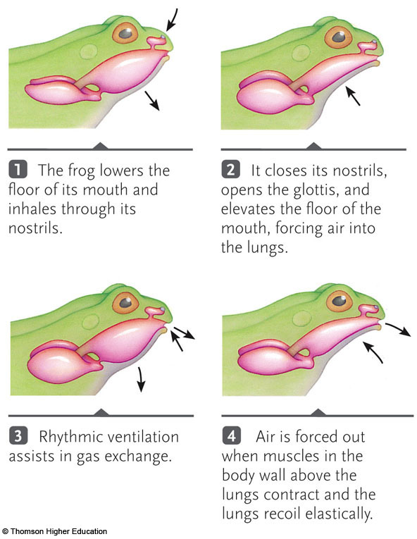

03-5

